**Objective 1:** Create a web page by **HTML** can be Educational/Business  
**Index.html**

<!DOCTYPE html>

<html lang="en">

<head>

  <meta charset="UTF-8">

  <meta name="viewport" content="width=device-width, initial-scale=1.0">

  <title>CyberTech | By Mohit Saraswat</title>

  <!-- <link rel="stylesheet" href="style.css"> -->

</head>

<body>

  <!-- Header -->

  <header class="header">

    <div class="container nav-container">

      <h1 class="logo">Cyber<span>Tech</span></h1>

      <nav>

        <ul class="nav-links">

          <li><a href="#home">Home</a></li>

          <li><a href="#about">About</a></li>

          <li><a href="#services">Services</a></li>

          <li><a href="#why">Why Us</a></li>

          <li><a href="#portfolio">Portfolio</a></li>

          <li><a href="#contact">Contact</a></li>

        </ul>

      </nav>

    </div>

  </header>

  <!-- Hero -->

  <section id="home" class="hero">

    <div class="hero-content">

      <h2>Empowering Businesses with Modern Tech Solutions</h2>

      <p>Website • App • Cybersecurity • DevOps • AI & More</p>

      <a href="#contact" class="btn">Let’s Build Together</a>

    </div>

  </section>

  <!-- About -->

  <section id="about" class="about">

    <div class="container">

      <h2>About <span>CyberTech</span></h2>

      <p>

        Founded by <strong>Mohit Saraswat</strong>, CyberTech is a freelancing-powered digital solutions company.

        We provide scalable, secure, and visually appealing technology solutions that empower startups and enterprises alike.

      </p>

    </div>

  </section>

  <!-- Services -->

  <section id="services" class="services">

    <div class="container">

      <h2>Our <span>Services</span></h2>

      <div class="service-cards">

        <div class="card"><h3>💻 Website Development</h3><p>Responsive, SEO-optimized websites built for performance.</p></div>

        <div class="card"><h3>📱 App Development</h3><p>Android & iOS apps designed for smooth user experiences.</p></div>

        <div class="card"><h3>🔐 Cybersecurity</h3><p>Data protection, audits, and penetration testing services.</p></div>

        <div class="card"><h3>⚙️ DevOps & Cloud</h3><p>Streamlined deployments and infrastructure automation.</p></div>

        <div class="card"><h3>🧩 API Integration</h3><p>Seamless connection between systems and platforms.</p></div>

        <div class="card"><h3>🎨 UI/UX Design</h3><p>Clean, modern, and user-focused design interfaces.</p></div>

        <div class="card"><h3>🛠 Maintenance</h3><p>Reliable post-launch support and updates.</p></div>

        <div class="card"><h3>🤖 AI & Data Solutions</h3><p>Machine learning insights and automation systems.</p></div>

      </div>

    </div>

  </section>

  <!-- Why Choose Us -->

  <section id="why" class="why">

    <div class="container">

      <h2>Why Choose <span>CyberTech</span>?</h2>

      <div class="why-list">

        <div class="why-card">✔ Freelancing Model — flexible & affordable</div>

        <div class="why-card">✔ End-to-End Tech Solutions</div>

        <div class="why-card">✔ Transparent Communication</div>

        <div class="why-card">✔ Secure & Scalable Builds</div>

        <div class="why-card">✔ 24/7 Support</div>

        <div class="why-card">✔ 100% Client Satisfaction</div>

      </div>

    </div>

  </section>

  <!-- Portfolio -->

  <section id="portfolio" class="portfolio">

    <div class="container">

      <h2>Our <span>Portfolio</span></h2>

      <div class="portfolio-grid">

        <div class="project"><img src="https://picsum.photos/400/250?1" alt=""><div class="overlay">Website Project</div></div>

        <div class="project"><img src="https://picsum.photos/400/250?2" alt=""><div class="overlay">App Project</div></div>

        <div class="project"><img src="https://picsum.photos/400/250?3" alt=""><div class="overlay">Cybersecurity Dashboard</div></div>

        <div class="project"><img src="https://picsum.photos/400/250?4" alt=""><div class="overlay">DevOps Automation</div></div>

      </div>

    </div>

  </section>

  <!-- Contact -->

  <section id="contact" class="contact">

    <div class="container">

      <h2>Get in <span>Touch</span></h2>

      <p>Let’s collaborate and bring your project idea to life.</p>

      <form class="contact-form">

        <input type="text" placeholder="Your Name" required>

        <input type="email" placeholder="Your Email" required>

**<---------------code------------->**

        <textarea rows="5" placeholder="Your Message" required></textarea>

        <button type="submit" class="btn">Send Message</button>

      </form>

    </div>

  </section>

  <!-- Footer -->

  <footer class="footer">

    <p>© 2025 CyberTech | Built with 💻 by <strong>Mohit Saraswat</strong></p>

  </footer>

</body>

</html>

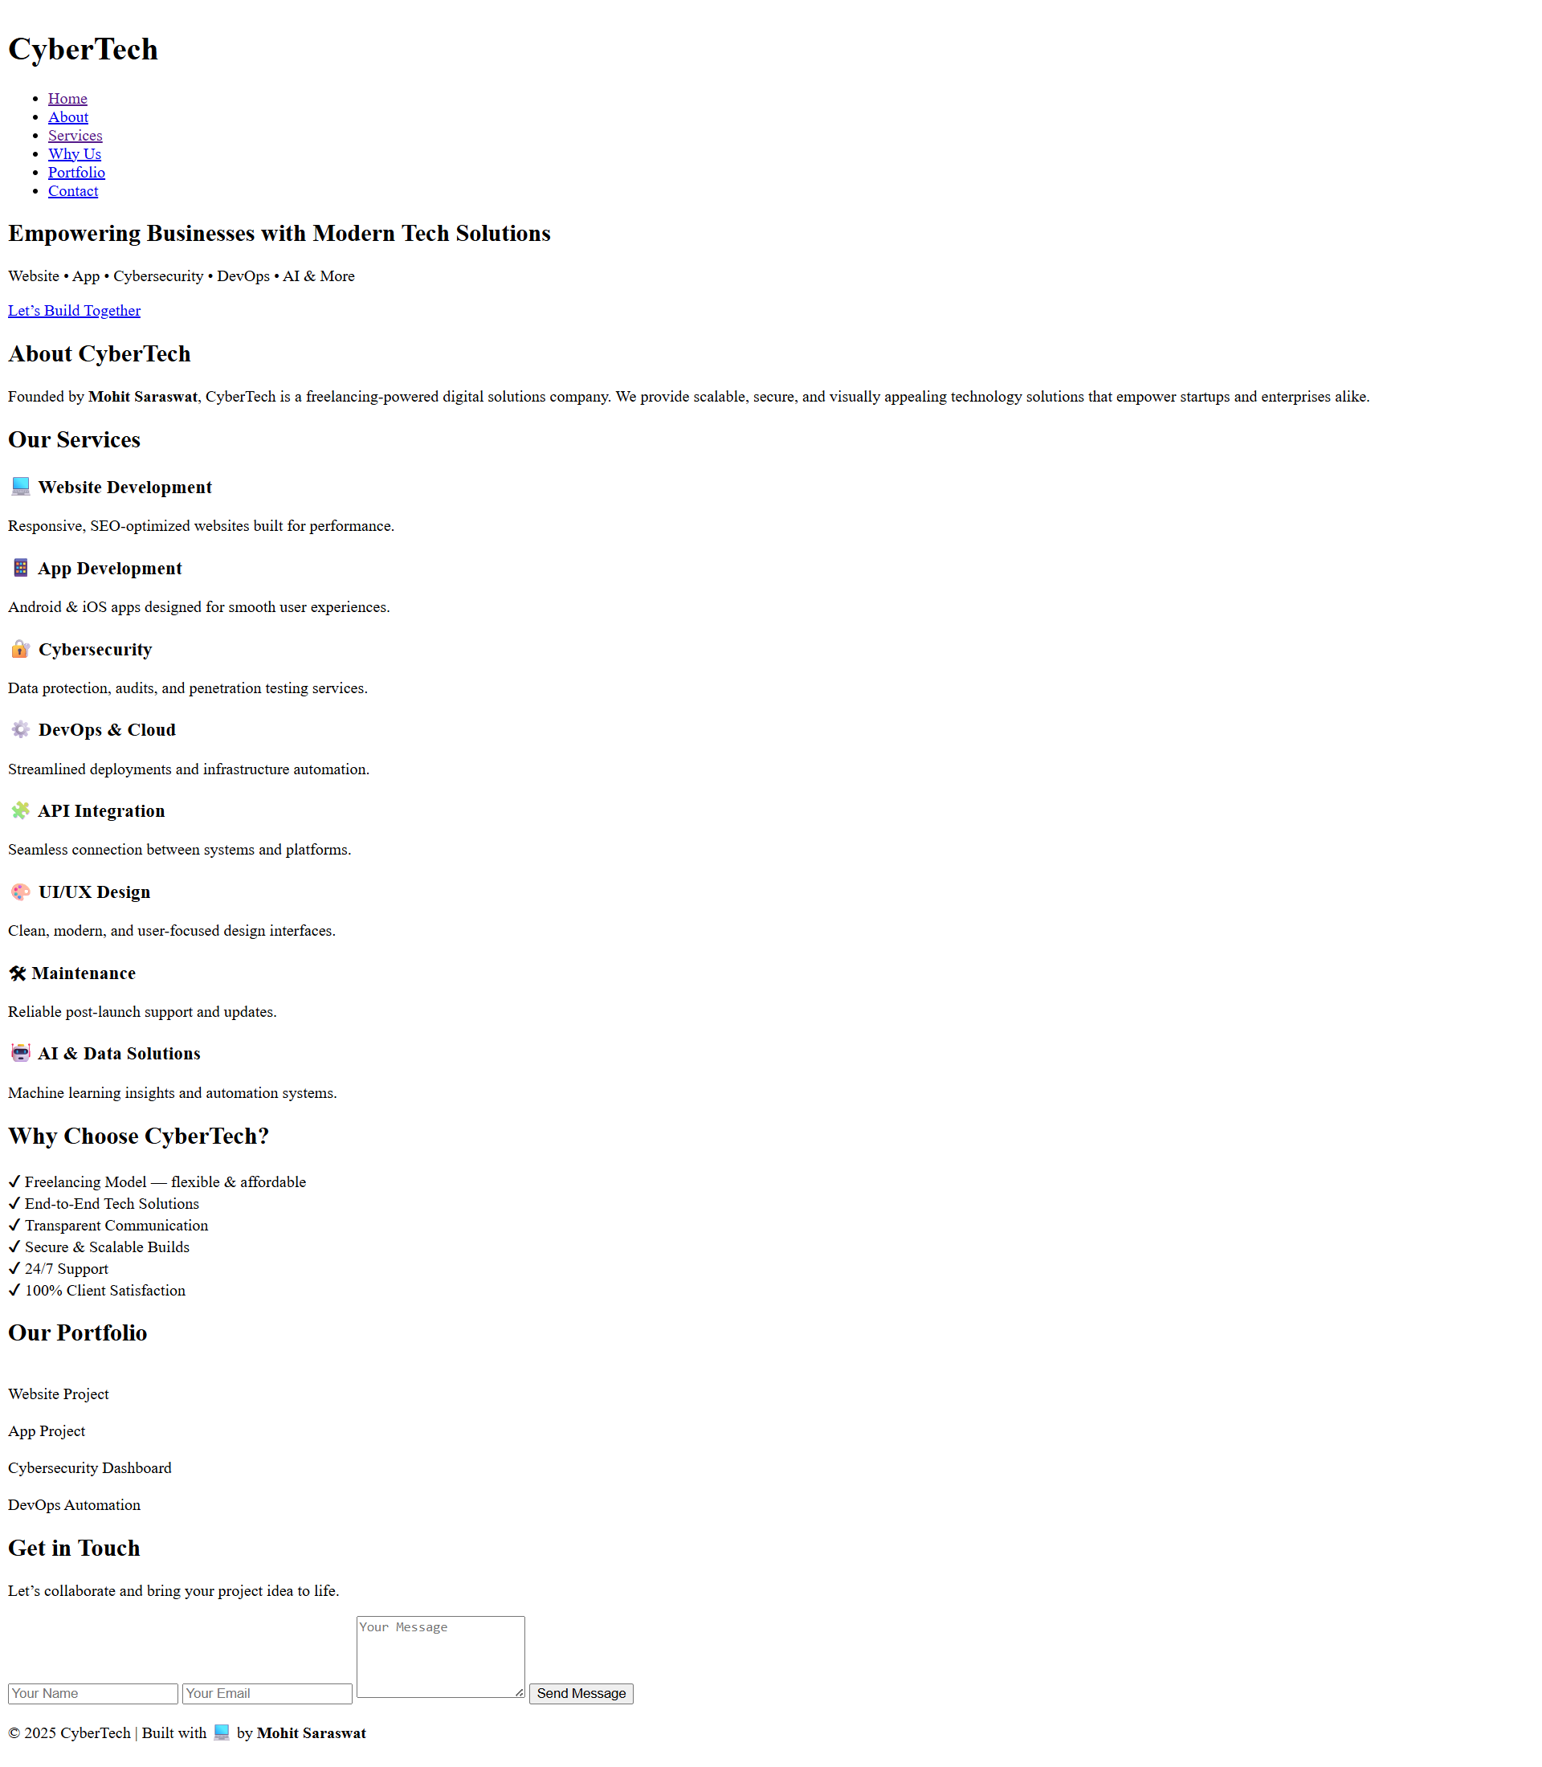

**Objective 2:** Implement of **CSS** on **Index.HTML** file  
**style.css**

/* Reset */

* {

  margin: 0; padding: 0;

  box-sizing: border-box;

  font-family: 'Poppins', sans-serif;

}

body {

  background: #0a0a0c;

  color: #fff;

  scroll-behavior: smooth;

}

/* Header */

.header {

  position: fixed;

  top: 0; width: 100%;

  background: rgba(10,10,14,0.9);

  backdrop-filter: blur(10px);

  padding: 15px 0;

  z-index: 100;

}

.nav-container {

  display: flex; align-items: center; justify-content: space-between;

  width: 85%; margin: auto;

}

.logo {

  font-size: 1.8rem; font-weight: 700; color: #fff;

}

.logo span {

  background: linear-gradient(90deg,#007bff,#00d4ff);

  -webkit-background-clip: text;

  color: transparent;

}

.nav-links {

  list-style: none; display: flex; gap: 25px;

}

.nav-links a {

  text-decoration: none; color: #fff; font-weight: 500;

  transition: 0.3s;

}

.nav-links a:hover { color: #00d4ff; }

/* Hero */

.hero {

  background: linear-gradient(135deg,#00152a,#00315a,#000);

  min-height: 100vh;

  display: flex; align-items: center; justify-content: center;

  text-align: center; padding: 120px 20px;

}

.hero h2 {

  font-size: 2.4rem;

  background: linear-gradient(90deg,#00d4ff,#007bff);

  -webkit-background-clip: text;

  color: transparent;

  margin-bottom: 15px;

}

.hero p { color: #cfd8dc; margin-bottom: 25px; }

.btn {

  background: linear-gradient(90deg,#007bff,#00d4ff);

  padding: 12px 30px; border-radius: 30px;

  text-decoration: none; color: #fff; font-weight: 600;

  transition: 0.3s;

}

.btn:hover { opacity: 0.85; }

/* Section Titles */

section h2 {

  text-align: center; font-size: 2rem;

  margin-bottom: 20px;

}

section h2 span { color: #00d4ff; }

/* About */

.about {

  padding: 100px 0;

  background: #0f0f12;

  text-align: center;

}

.about p {

  width: 70%; margin: 20px auto;

  color: #b0bec5; line-height: 1.7;

}

/* Services */

.services {

  padding: 100px 0;

  background: #0b0b0d;

  text-align: center;

}

.service-cards {

  margin-top: 50px;

  display: grid;

  grid-template-columns: repeat(auto-fit,minmax(250px,1fr));

  gap: 25px;

}

.card {

  background: linear-gradient(145deg,#0f0f12,#1b1b1f);

  padding: 30px; border-radius: 15px;

  transition: transform 0.3s, box-shadow 0.3s;

}

.card:hover {

  transform: translateY(-8px);

  box-shadow: 0 0 20px rgba(0,180,255,0.3);

}

.card h3 { color: #00d4ff; margin-bottom: 10px; }

/* Why Choose */

.why {

  background: linear-gradient(135deg,#00152a,#000);

  padding: 100px 0;

  text-align: center;

}

.why-list {

  display: grid;

  grid-template-columns: repeat(auto-fit,minmax(200px,1fr));

  gap: 20px; margin-top: 40px;

}

.why-card {

  background: #121212;

  padding: 20px;

  border-radius: 12px;

  border-left: 4px solid #00d4ff;

  transition: transform 0.3s;

}

.why-card:hover { transform: scale(1.05); }

/* Portfolio */

.portfolio {

  background: #0f0f12;

  padding: 100px 0;

  text-align: center;

}

.portfolio-grid {

  margin-top: 50px;

  display: grid;

  grid-template-columns: repeat(auto-fit,minmax(250px,1fr));

  gap: 25px;

}

.project {

  position: relative; overflow: hidden; border-radius: 15px;

}

**<---------------code------------->**

.project img {

  width: 100%; border-radius: 15px;

  transition: transform 0.4s;

}

.project:hover img { transform: scale(1.1); }

.overlay {

  position: absolute; bottom: 0; left: 0; right: 0;

  background: rgba(0,0,0,0.7);

  color: #00d4ff; padding: 10px;

  opacity: 0; transition: 0.3s;

}

.project:hover .overlay { opacity: 1; }

/* Contact */

.contact {

  background: linear-gradient(135deg,#00152a,#000);

  padding: 100px 0; text-align: center;

}

.contact-form {

  width: 70%; margin: 40px auto 0;

  display: flex; flex-direction: column; gap: 15px;

}

.contact-form input,

.contact-form textarea {

  padding: 15px; border: none; border-radius: 10px;

  background: #121212; color: #fff; outline: none;

}

/* Footer */

.footer {

  background: #0f0f12;

  text-align: center; padding: 25px 0;

  color: #aaa; font-size: 0.9rem;

}

.footer strong { color: #00d4ff; }

@media(max-width:768px){

  .nav-links { display: none; }

  .about p, .contact-form { width: 90%; }

}

@media(max-width:480px){

  .hero h2 { font-size: 1.8rem; }

  .btn { padding: 10px 25px; }

}

